1. select \* from salgrade

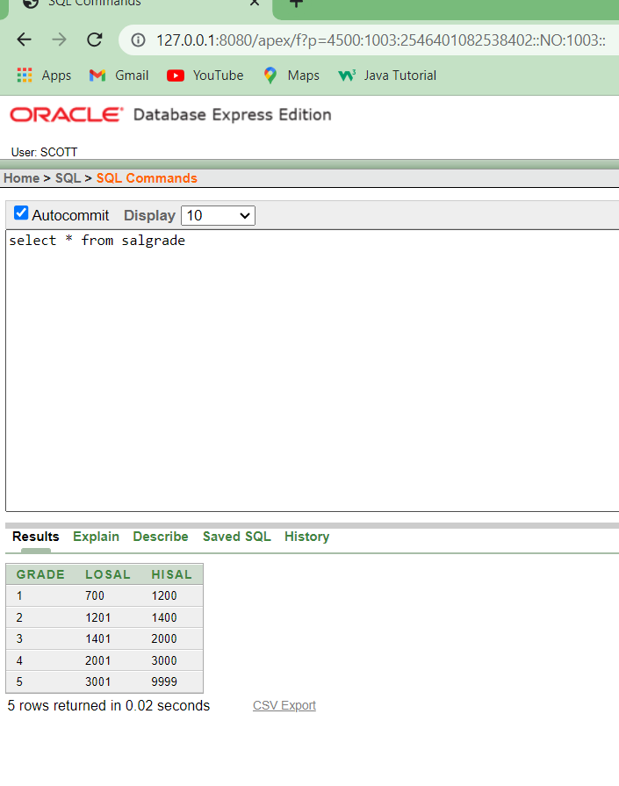

1. select deptno from dept;

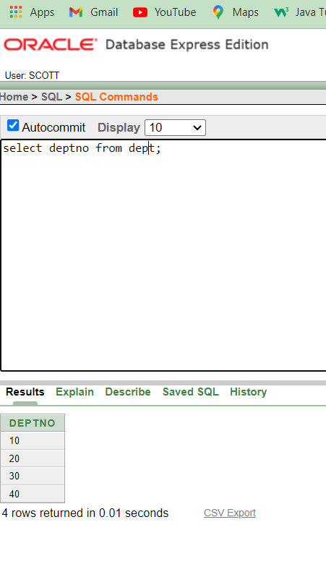

3. select (sal+sal\*0.05) "5% Increment" from emp; 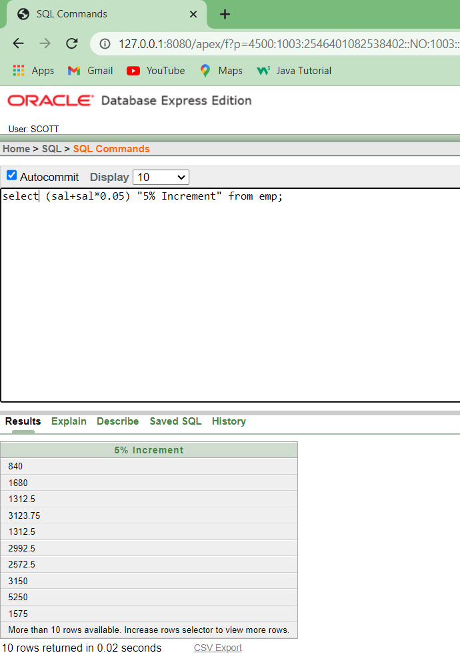

5. select \* from emp where ename='BLAKE'; 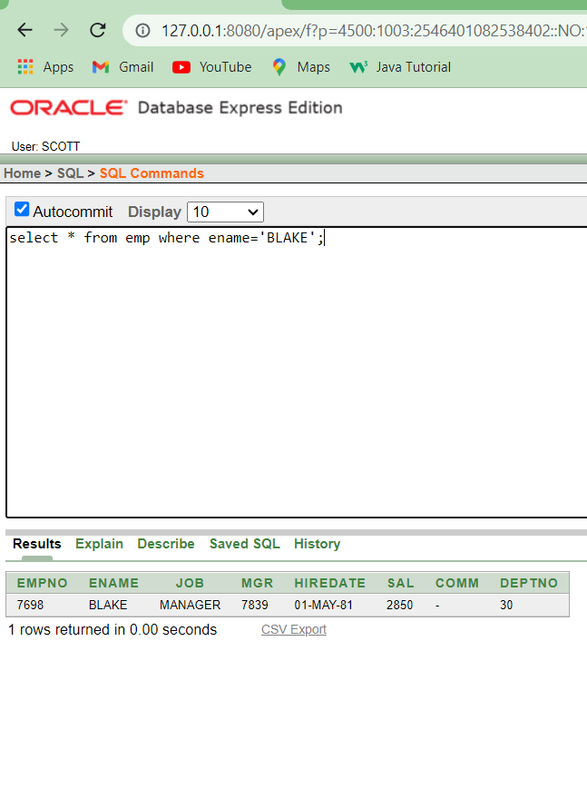

6. select ename||' is hired on ' ||hiredate||' as a '||job"Description" from emp where hiredate between '17-dec-80' and '28-sep-81'; 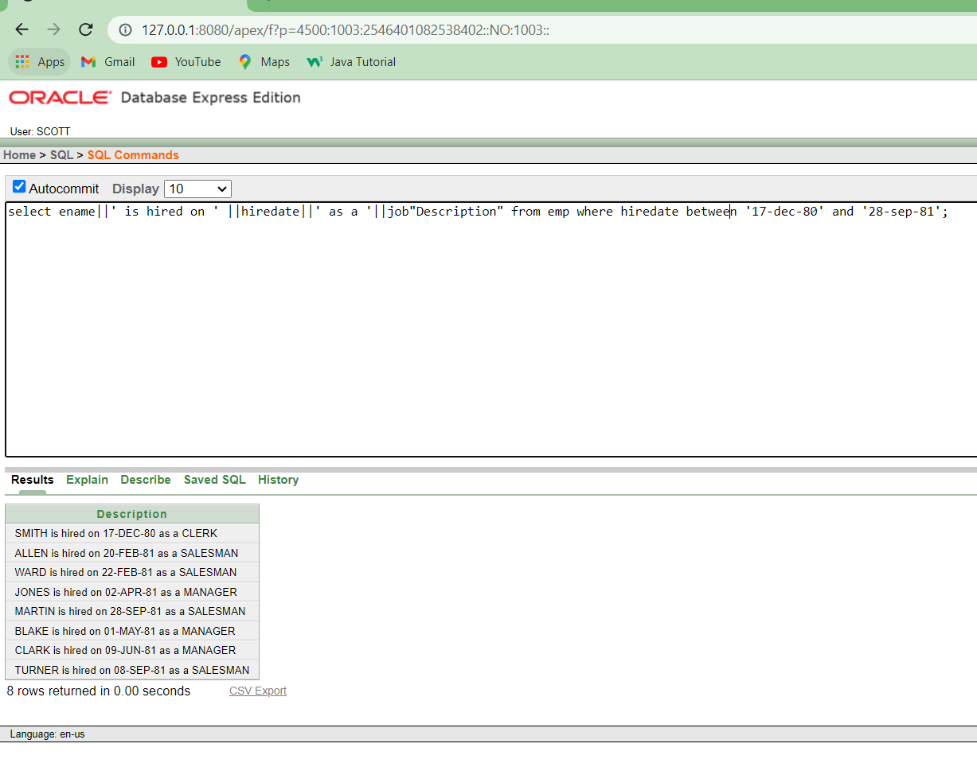

7. describe emp;

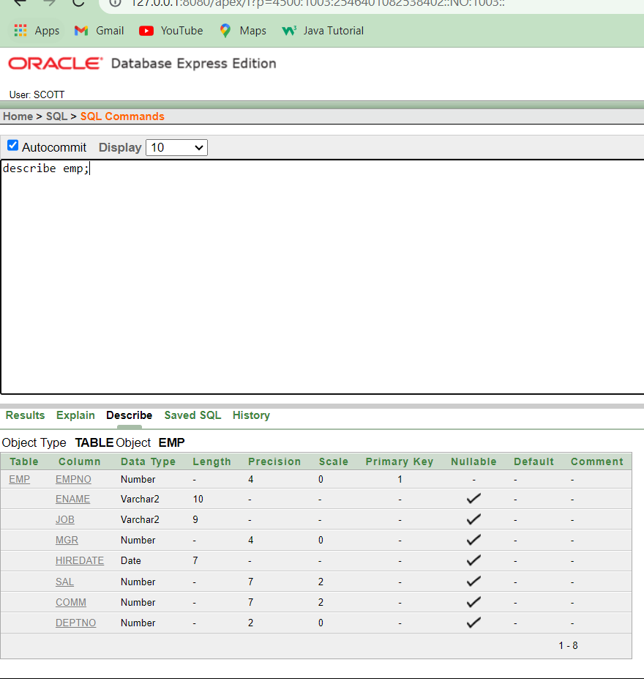

describe dept;

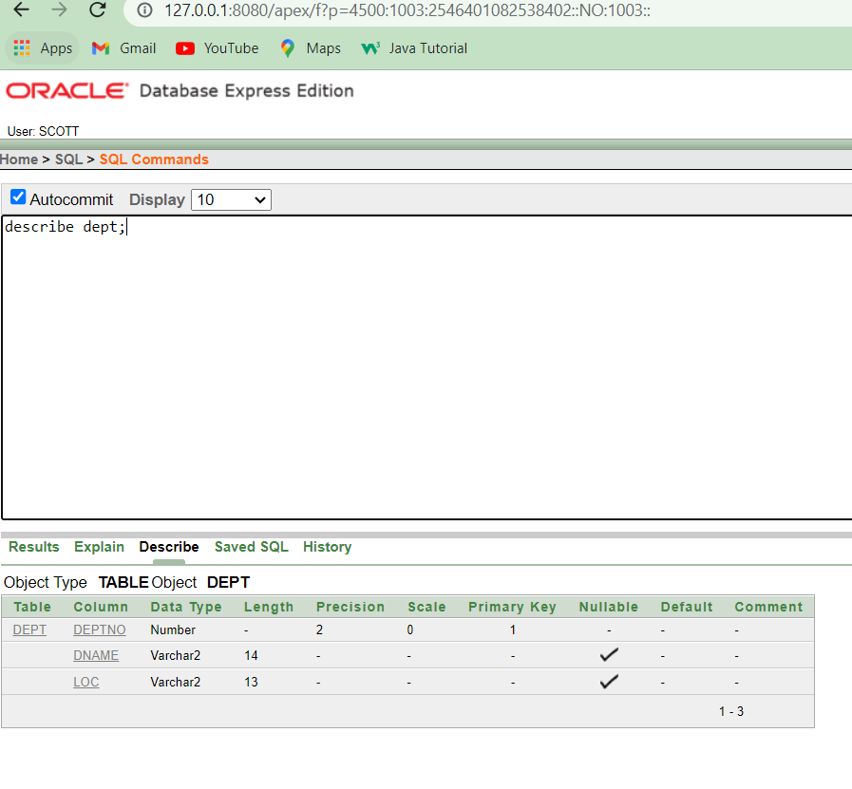

describe salgrade;

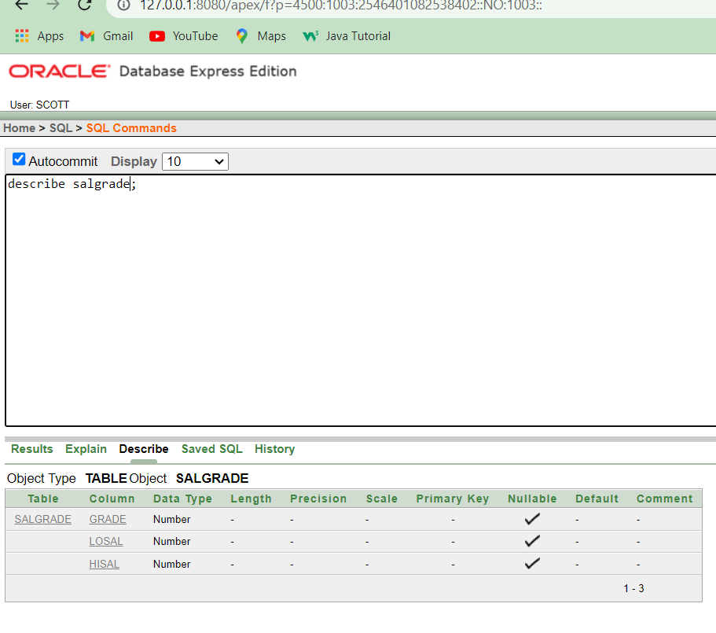

describe bonus;

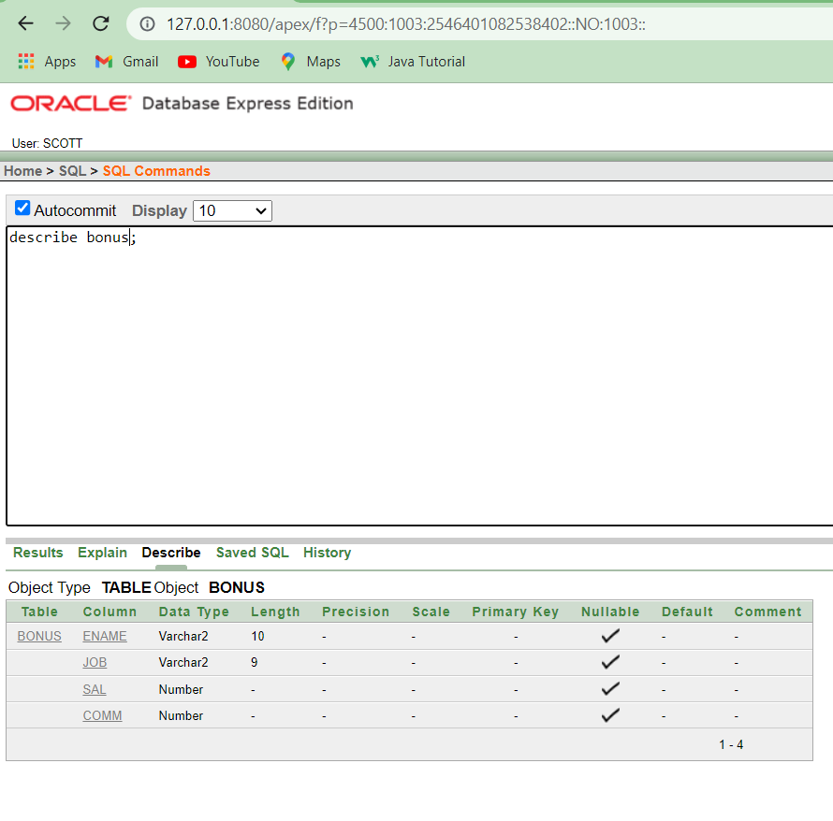

8. select distinct job from emp;

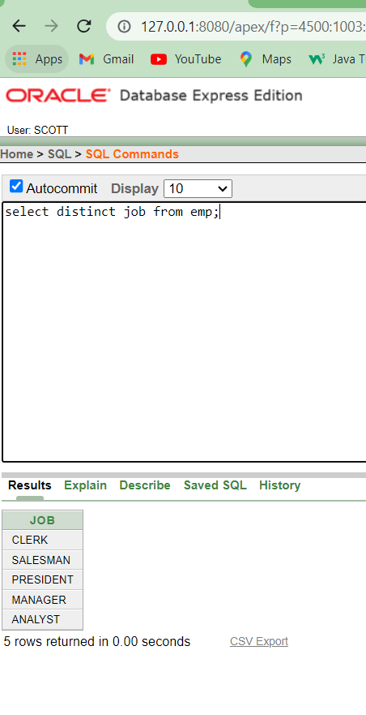

4.select ename, sal, (sal+sal\*0.05) "5% Increment" from emp;

